Java Servlets 3.0
Lab Book




Document Revision History

Date | Revision No. | Author | Summary of Changes
May 2015 | 4.0 | Yukti A Valecha | Revamped from Servlets 2.5 to Servlets 3.0
May 2016 | 4.1 | Yukti A Valecha /Anjulata | Revamped as per revised course contents

Table of Contents
Document Revision History 2
Table of Contents 3
Getting Started 4
Overview 4
Setup Checklist for Servlets 3.0 4
Instructions 4
Lab 1. Servlet Basics 5
Lab 2. Request and Response Objects 6
Lab 3. Database Connectivity 9
Lab 4. Inter-Servlet Communication 24
Lab 5. Session Management 25

Getting Started

Overview
This lab book is a guided tour for learning Servlets 3.0. It comprises scenario based applications and ‘To Do’ assignments. Flow diagrams and screen snap shots are provided where necessary.

Setup Checklist for Servlets 3.0
Here is what is expected on your machine in order for the lab to work.
Minimum System Requirements
- Intel Pentium 90 or higher (P166 recommended)
- Microsoft Windows 95, 98, or NT 4.0, 2k, XP.
- Memory: 32MB of RAM (64MB or more recommended)
- Java SE version 8
- Internet Explorer 6.0 or higher
- Connectivity to Oracle database
- WildFly server Version 8.1.0

Please ensure that the following is done:
- Eclipse_JEE_Luna (4.x) is installed.

Instructions

- All lab assignments should refer coding standards.
- Create a directory by your name in drive <drive>. In this directory, create a subdirectory servlet_assgn. For each lab exercise create a directory as lab <lab number>.
You may also look up the on-line help provided in JEE documentation

- Servlet Basics

Goals | - Understanding Servlet Basics and Invocation
Time | 0.5 Hour

  - Create a Servlet program that will print the system date and time.

Note: The Servlet should be invoked in the following ways:
- On clicking of Hyper Link in html page
- On clicking of button in html page
- On typing the servlet URL pattern directly in Address bar of browser

- Request and Response Objects

Goals | - Understanding the request and response objects
Time | 2 Hours

2.1: Design a login Page accepting username and password in HTML. The credentials need to be authenticated in Servlet.
The credentials could be validated by using hard coded values for username and password.
If user is valid then display HTML page as “Success” and display HTML page as “Failure” if user is invalid.

Note:
- Checking could be done by using private method inside servlet.
- The redirection to HTML pages is done using response.sendRedirect(String URLPattern) method

Refer below figure for HTML Login Page:

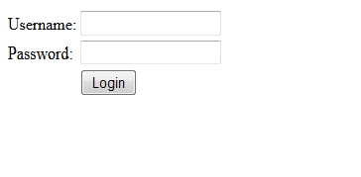
Figure 1

In extension to the previous assignment print the following details extracted from the ‘Request’ object….
- MIME type accepted by the client
- The locale setting
- Data transferred in bytes

2.2: Consider a webpage which is displaying live stock market status. For such type of page, you would need to refresh your web page regularly using refresh or reload button with your browser.
Java Servlet makes this job easy by providing you a mechanism where you can make a webpage in such a way that it would refresh automatically after a given interval.
Consider the servlet code snippet below and complete the blank space left for automatic refresh to happen and auto-load page after 5 seconds.

Refer below figure:

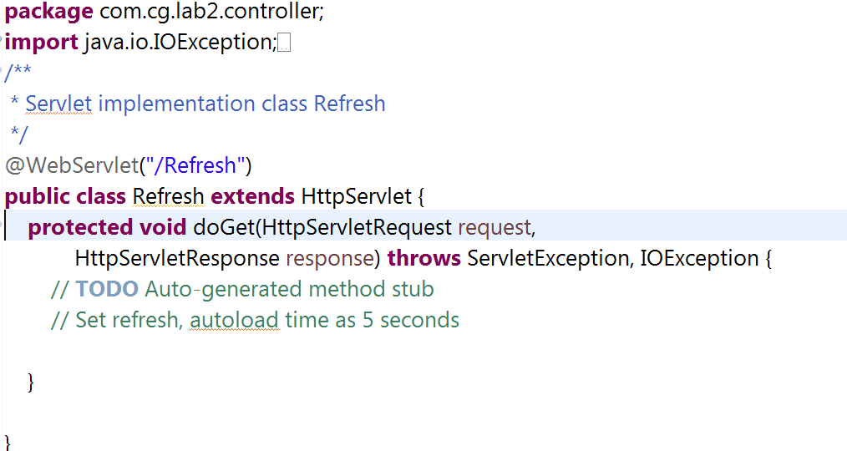

Figure 2

Create a servlet that will redirect the current web application to ISPACE.

See below figure for same:

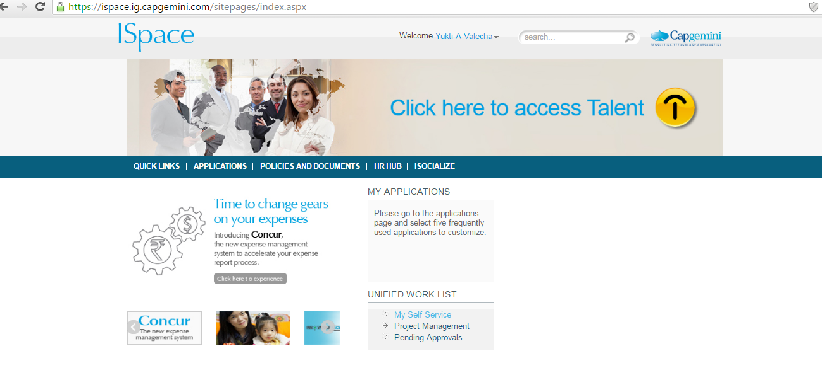

Figure 3

- Database Connectivity

Goals | - Creating DB connection pool with WildFly
Time | 2 Hours

3.1: Steps to configure Database connection pool in WildFly:

Need to add Management User, Run D:\wildfly-8.1.0.Final\bin>add-user.bat
Create a Management User. Select Option (a)

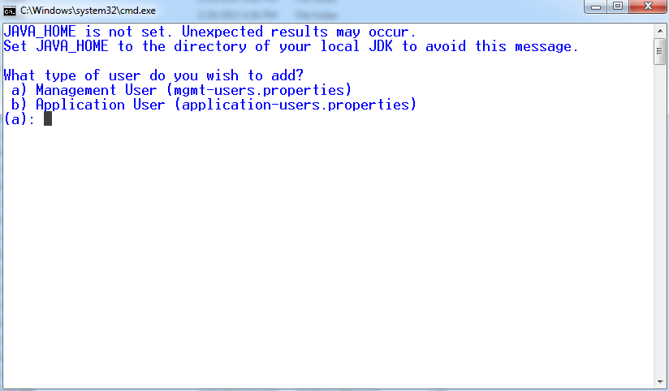
Figure 4

Enter Username / Password

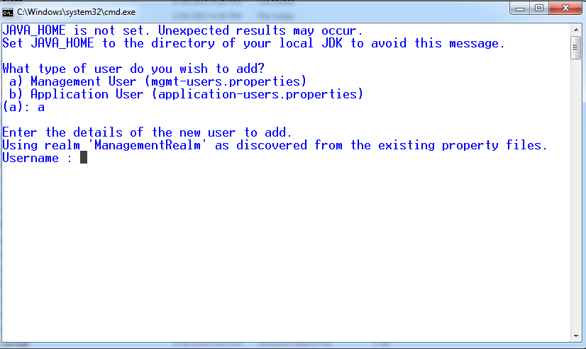
Figure 5

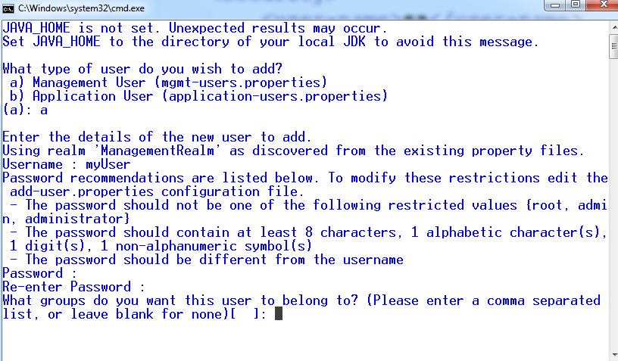
Figure 6

What Group this User should belong to – Leave as blank, Add the user to Management Realm with Option Yes.
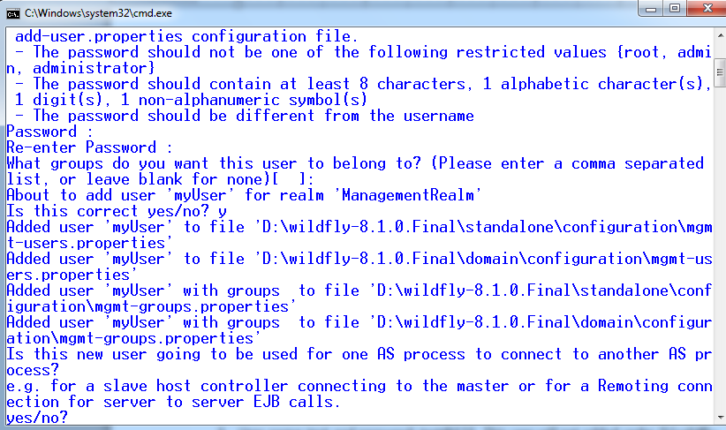
Figure 7

No need to add the User for server EJB Calls.

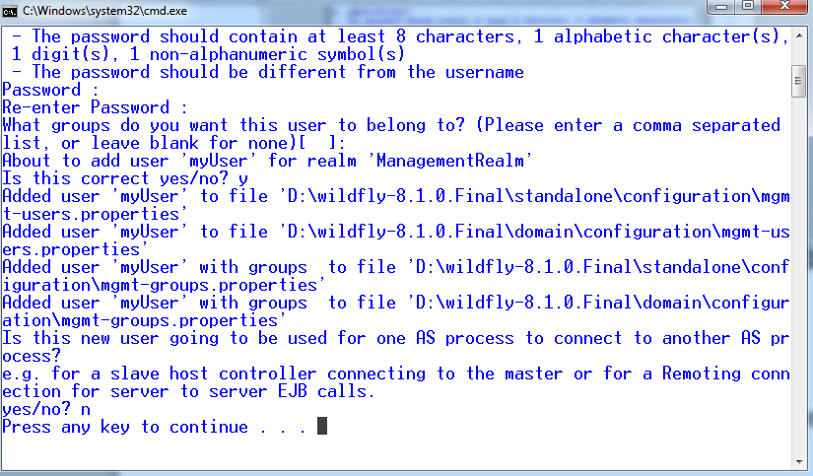
Figure 8

User name: myUser and password: myUser@12.This user will get added under D:\wildfly-8.1.0.Final\standalone\configuration\mgmt-users.properties

Start the WildFly server.
Open the link: http://localhost:9090/console/.Enter the credentials to log in (Which you have created under Management Realm).

Note: Default port number is 8080. But due to port number conflict, it has been changed to 9090.

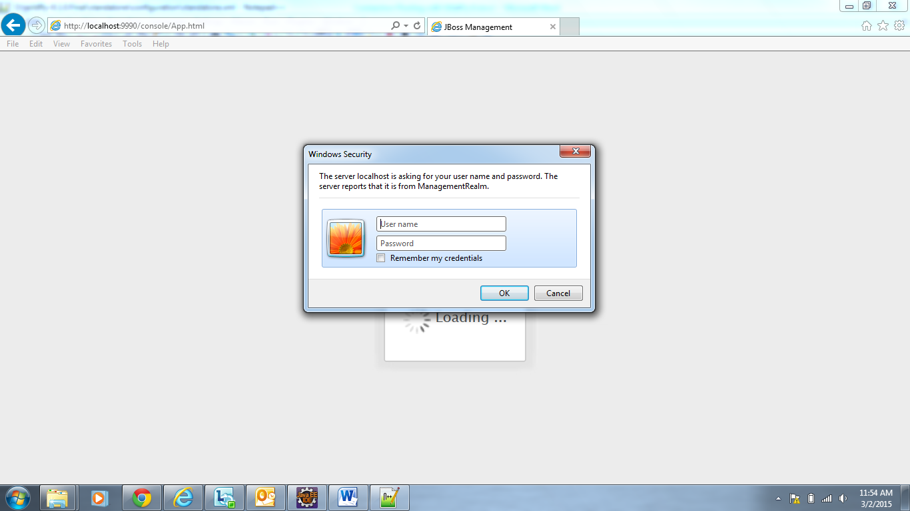
Figure 9

Following is figure of Home Page
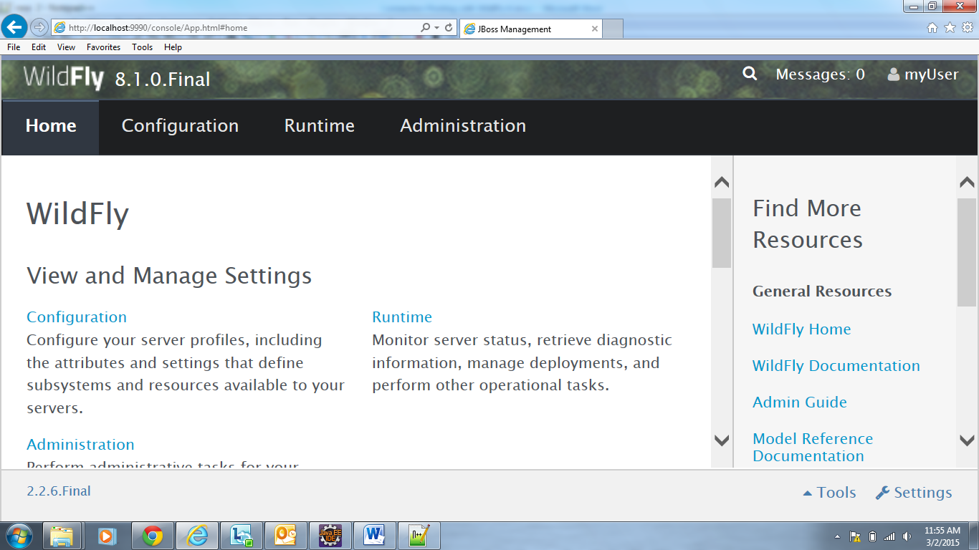
Figure 10

Before creating a datasource we need to deploy the JDBC driver class file to use for connecting to DB.
  - Thus we need to use ojdbc6_g.jar (which is JDBC 4 complaint)
  - Any JDBC4-compliant driver is automatically recognized by WildFly and made available for new datasources.
  - Go to Runtime > Server > Manage Deployments and click on Add to deploy the Oracle complaint Jar file

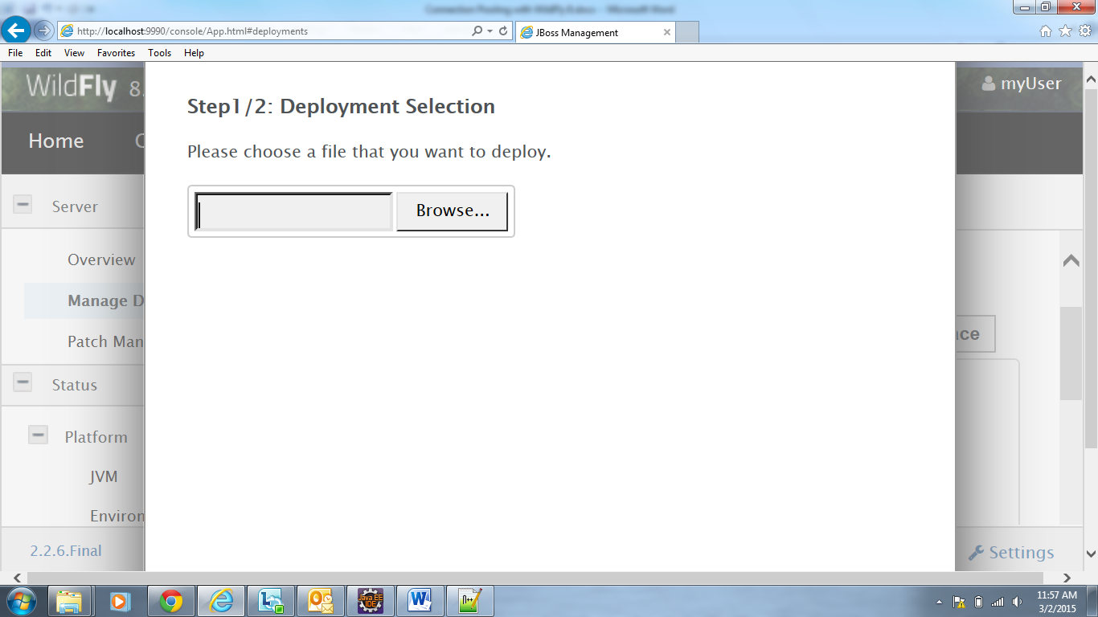
Figure 11
Give the path from your local machine (where ojdbc6_g.jar) is present

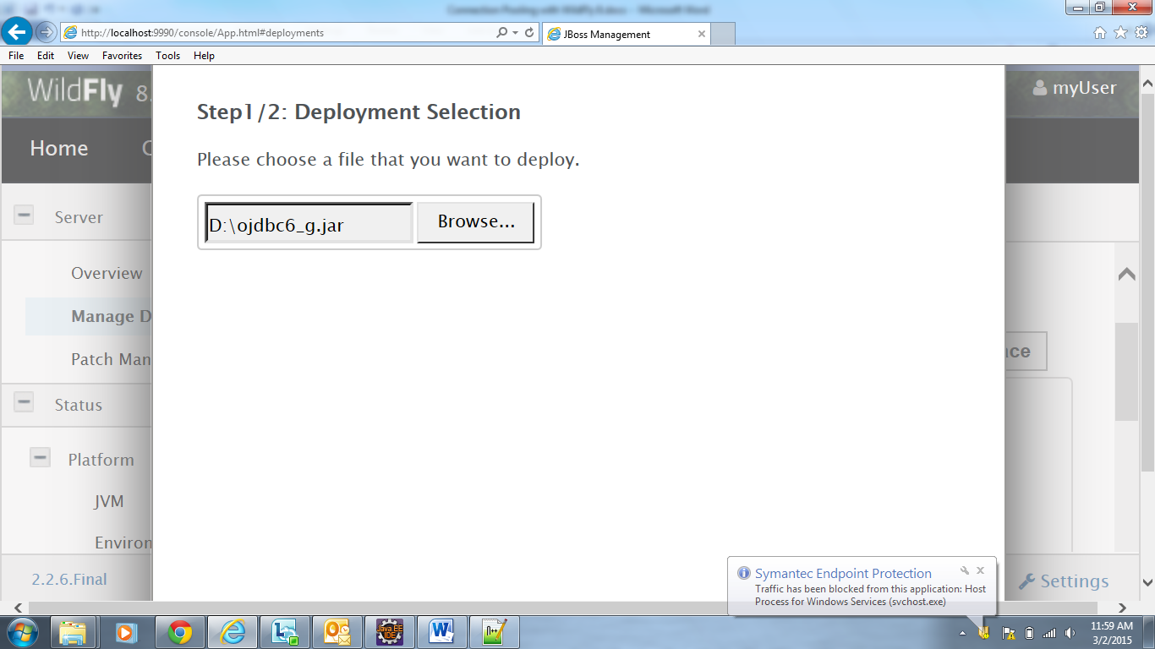
Figure 12

  - Click Next. Supply the Name and Runtime Name with which you want to identify Oracle jar file

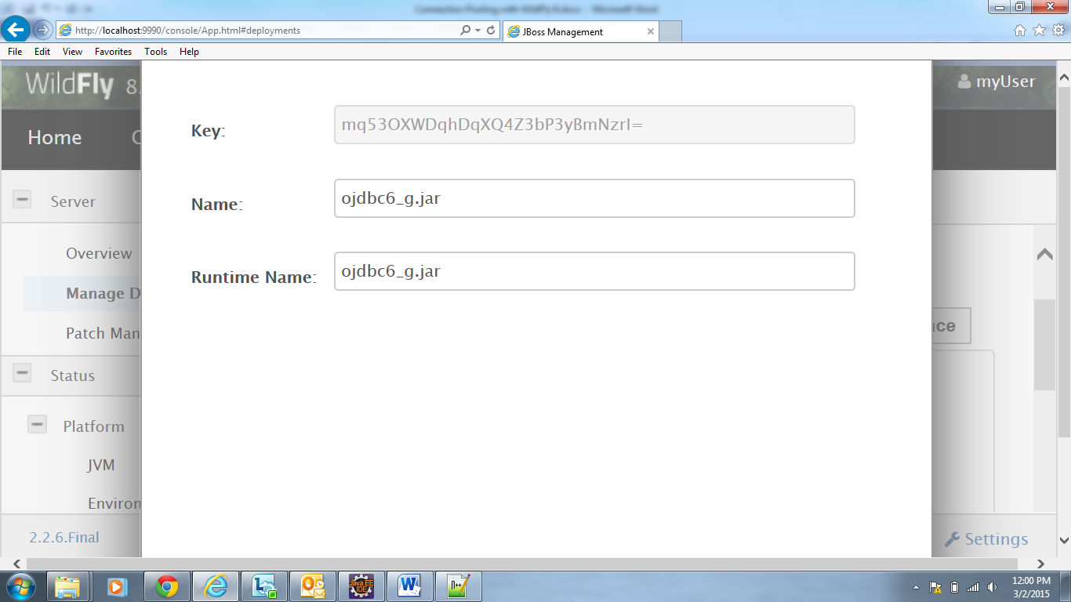
Figure 13
Click on Save

  - After Oracle jar file is deployed, click on Enable/Disable to make it available for Datasources

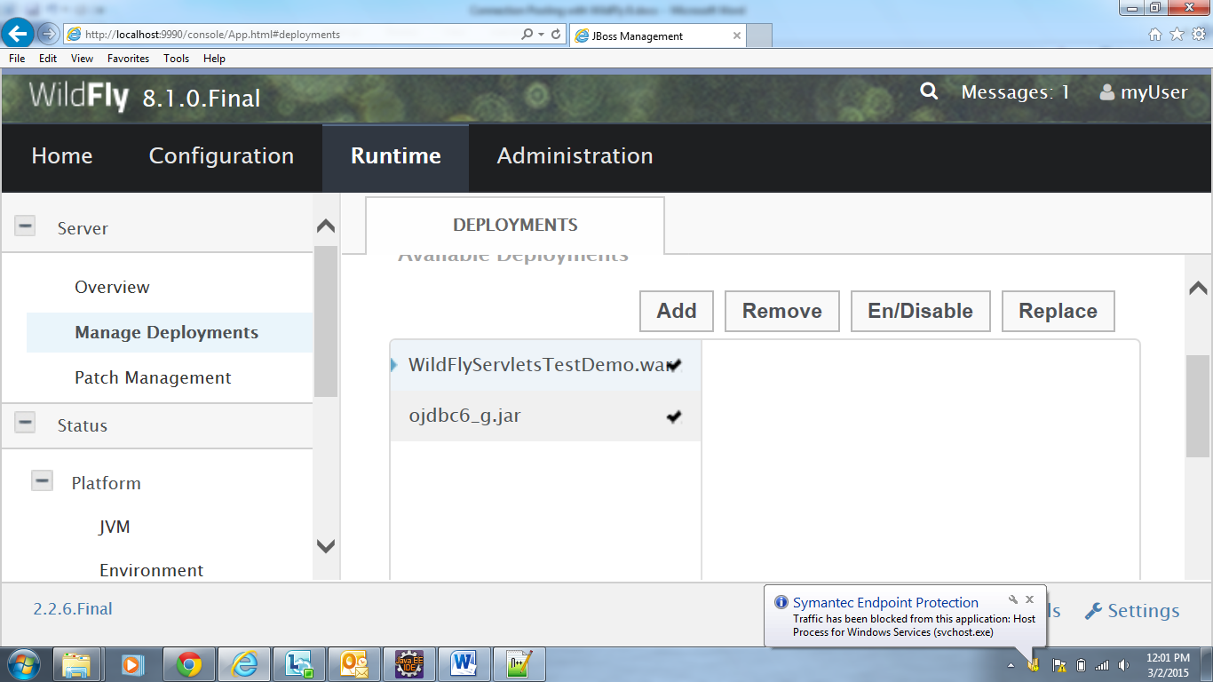
Figure 14

Go to Home > Create a datasource > Datasources. Click on Add to add a Datasource

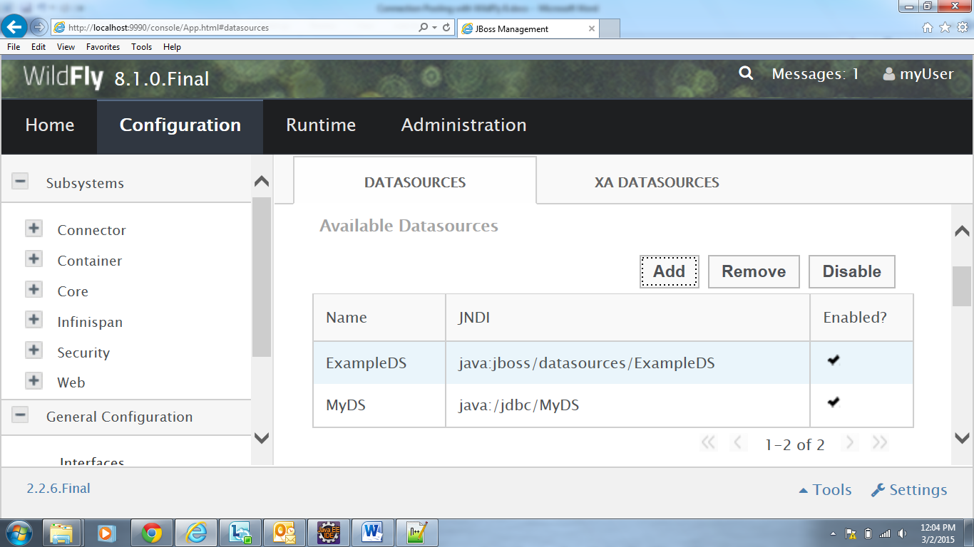
Figure 15

Supply Connection Pool Name (example: MyDS): as well as JNDI Name: (example: java:/jdbc/MyDS)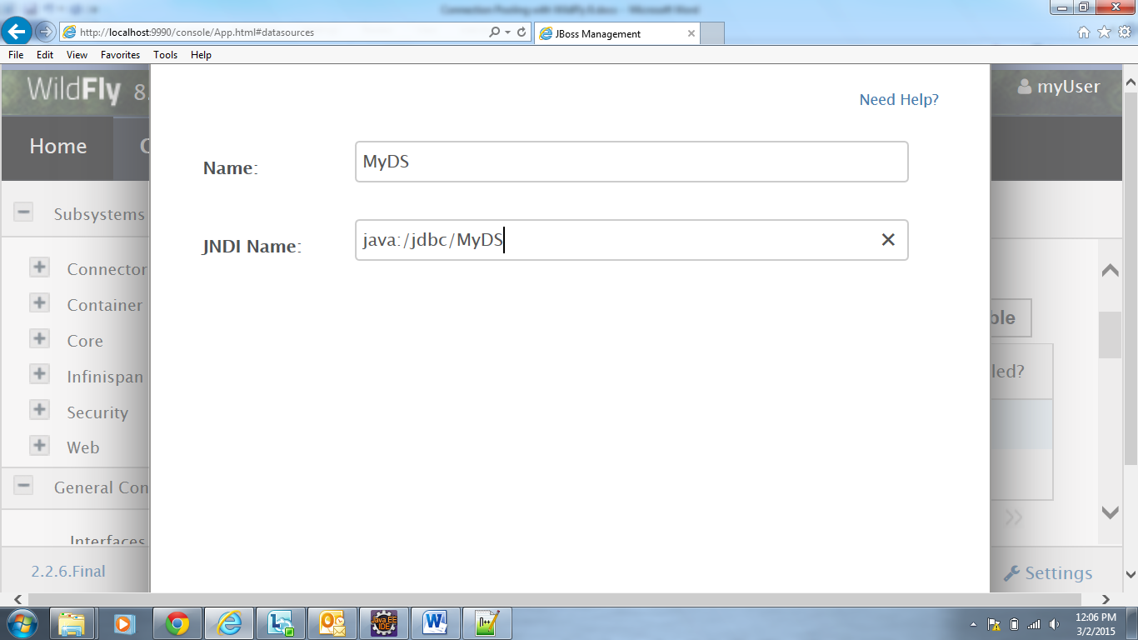
Figure 16

Click Next > Select the Detected Driver > ojdbc6_g.jar
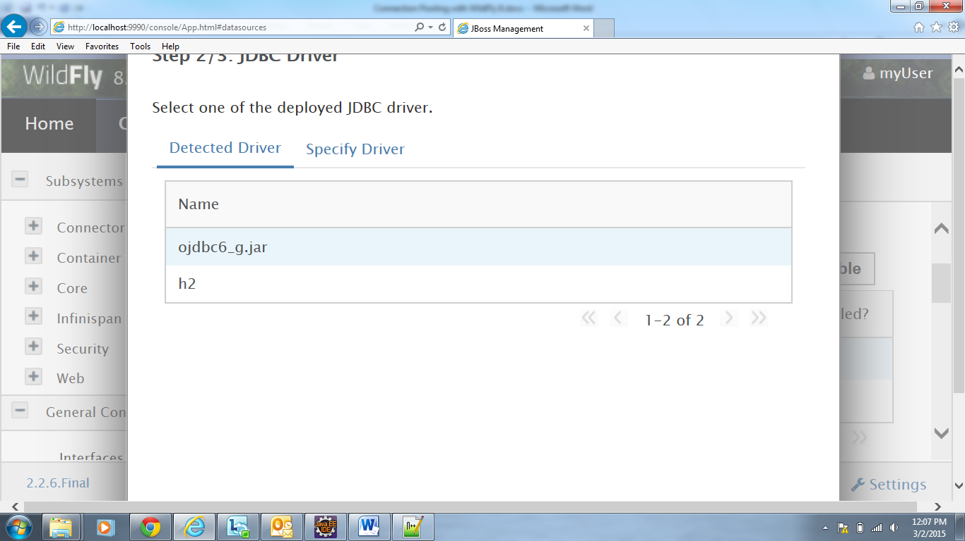
Figure 17

Click Next > Supply Connection URL (jdbc:oracle:thin:@localhost:1522:XE), Username (system), Password (yukti) . These details are with respect to Oracle 11g installed on my machine. These details have to be filled in with respect to the Database you want to connect to.
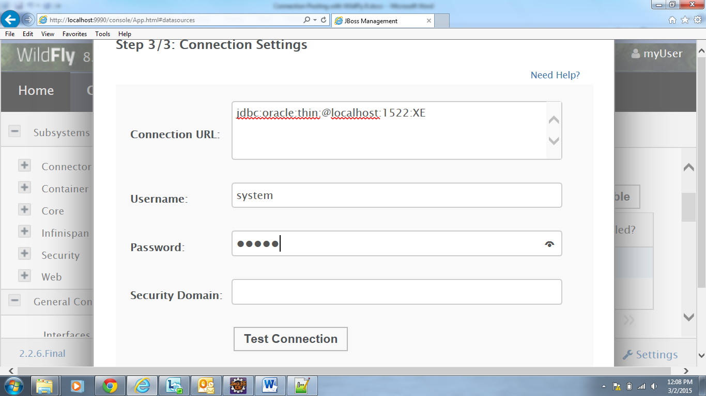
Figure 18

Click on Test Connection. It should show Connection tested successfully

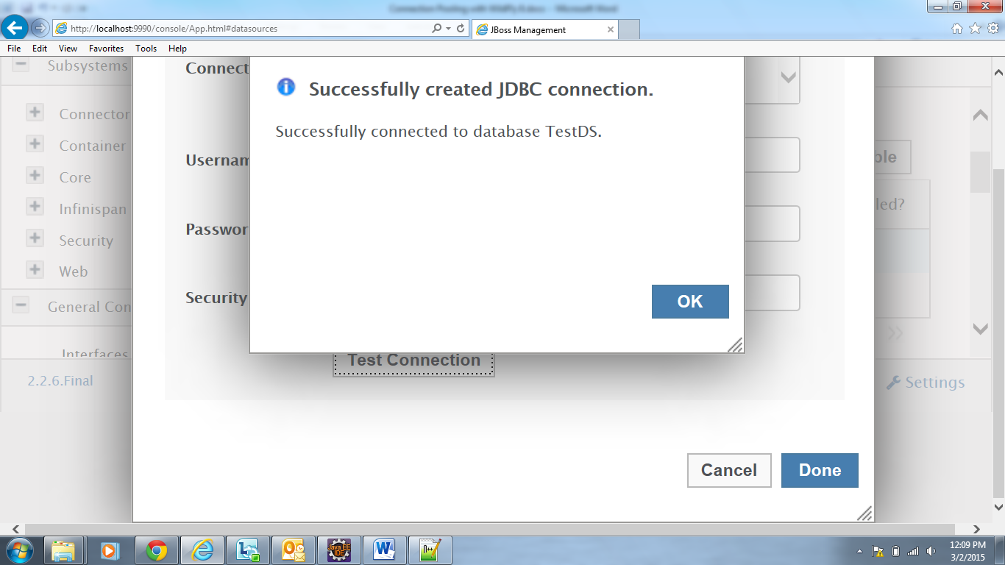
Figure 19

Click on Done to create Datasource.
Select the Datasource and Click on Enable button to make it available for Connection Pooling.

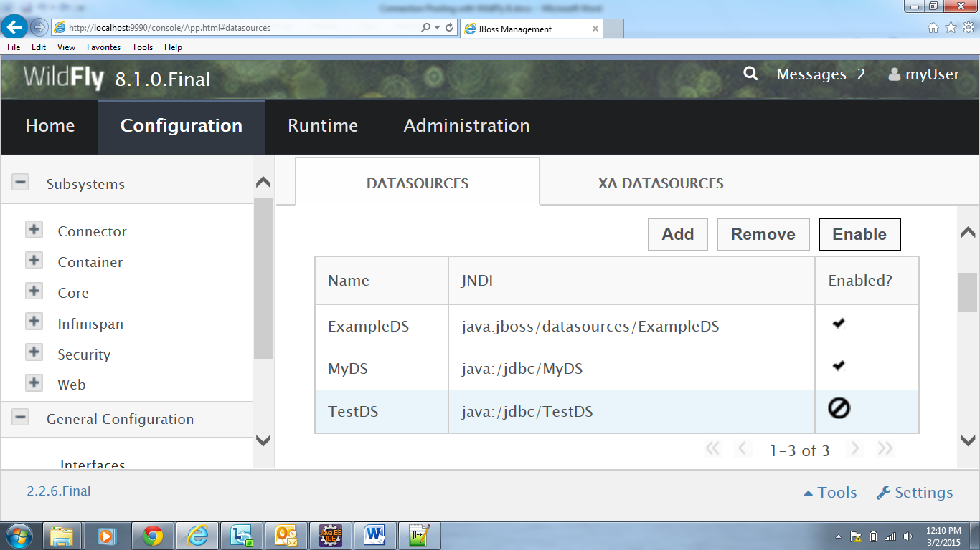
Figure 20

Click on Confirm to Enable Datasource.

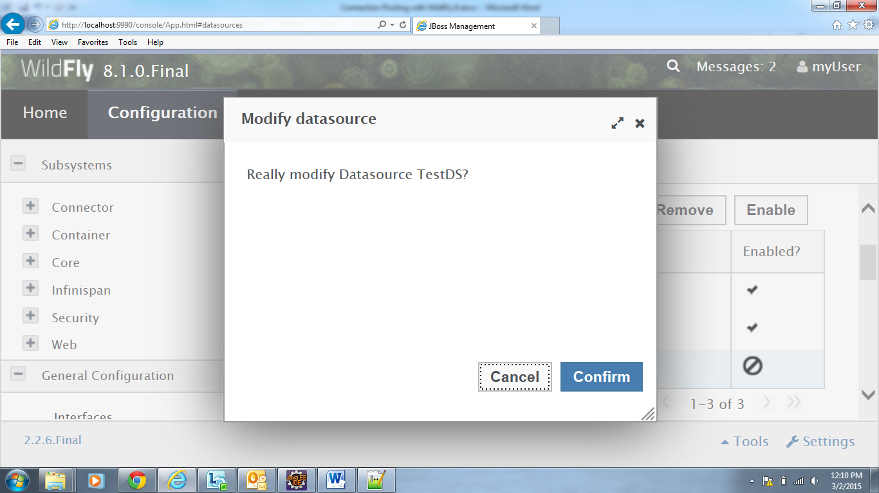
Figure 21
A check mark now appears on Enabled Datasource
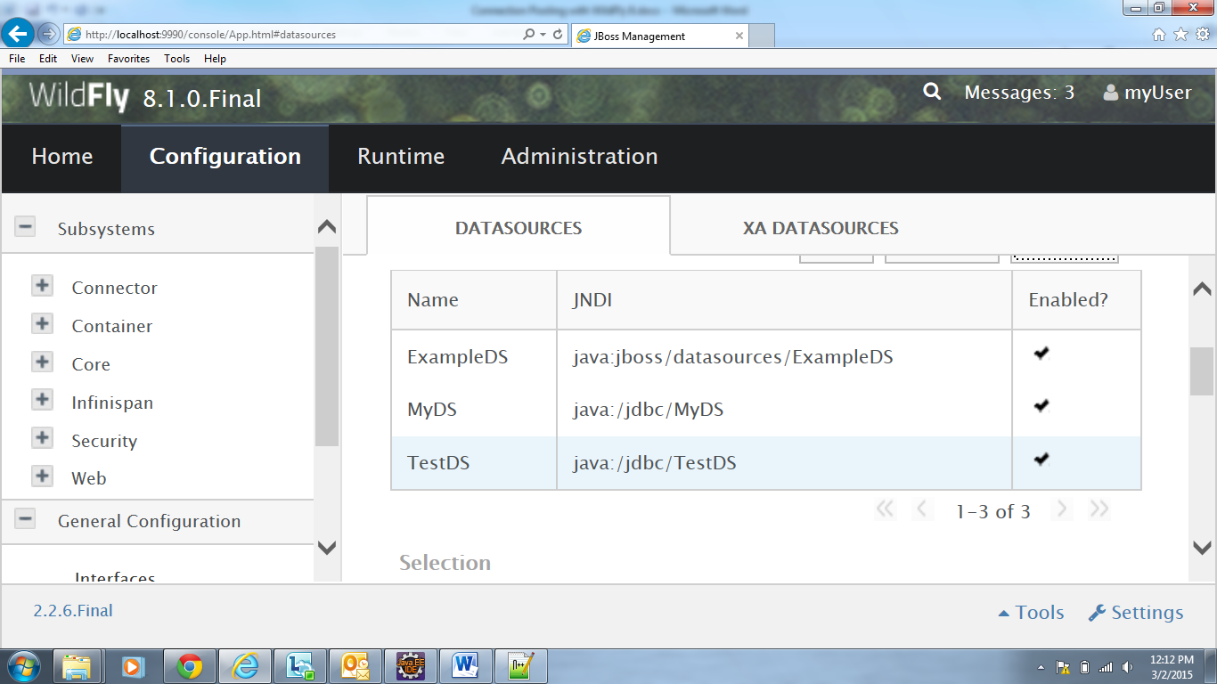
Figure 22

It should now be available on the page of JDBC Datasources
These Datasource mappings would be reflected in standalone.xml file (D:\wildfly-8.1.0.Final\standalone\configuration\standalone.xml). Check Datasource tag in this file.
Write Servlet code to test the connection Pool.

3.2: Design a registration page in HTML. Refer below figure.

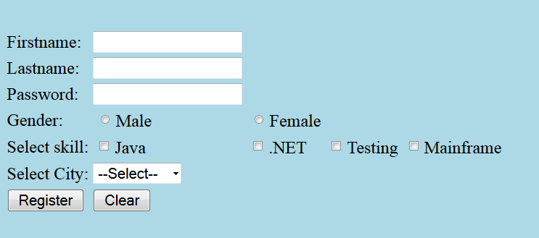
Figure 23

All the details entered in HTML page should be accepted by the Servlet.
The Servlet should connect via Connection Pool to database and store the user registration details in database table.

After the user details are inserted successfully in table (RegisteredUsers), display the message “Registration done!!!” in HTML page . Display “Registration failed!!!” in case of any exception .

Note:
- The redirection to HTML page is done using response.sendRedirect (String URLPattern) method
- The application needs to be developed using Layered architecture approach
- User can select more than one skillset, values of which should be concatenated
and stored in skillset column

Database Table used: RegisteredUsers

CREATE TABLE RegisteredUsers ( firstname VARCHAR (20), lastname VARCHAR (30), password VARCHAR (12) UNIQUE, gender CHAR, skillset VARCHAR (40), city VARCHAR (12));

Refer below figure for layered architecture:
DB

<<Controller>> RegistrationController

Registration.html
<<Service>>
RegisterServiceImpl
<<DAO>>
RegisterDAOImpl
UserDTO

Figure 24

- Inter-Servlet Communication

Goals | - Understanding Inter-Servlet Communication and data transfer between servlets
Time | 1 Hour

4.1: Modify the assignment in lab 3.2 and print all the users’ registered details on next
page.

Note:
- Make use of RequestDispatcher.forward(String URLPattern) method to navigate to next page
- To store all the users’ details make use of Request Scope

- Session Management

Goals | - Understanding Session Management
Time | 3 Hours

5.1 Rima is working in State electricity board project (eBill application) and is being given the requirement to accept the details online and calculate the net electricity bill amount and persist the details in database.

Refer the below script:

CREATE TABLE Consumers(
consumer_num NUMBER(6) PRIMARY KEY,
consumer_name VARCHAR2(20) NOT NULL,
address VARCHAR2(30)
);

INSERT INTO Consumers VALUES(100001,'Sumeet','Shivaji Nagar, Pune');
INSERT INTO Consumers VALUES(100002,'Meenal','M G Colony Panvel, Mumbai');
INSERT INTO Consumers VALUES(100003,'Neeraj','Whitefield, Bangalore');
INSERT INTO Consumers VALUES(100004,'Arul','Karapakkam, Chennai');

CREATE TABLE BillDetails(
bill_num NUMBER(6) PRIMARY KEY,
consumer_num NUMBER(6) REFERENCES Consumers(consumer_num),
cur_reading NUMBER(5,2),
unitConsumed NUMBER(5,2),
netAmount NUMBER(5,2),
bill_date DATE DEFAULT SYSDATE);

CREATE SEQUENCE seq_bill_num START WITH 100;

After login the admin user should be able to view the following UI:

[Note : Use login functionality implemented in Lab 2.1]

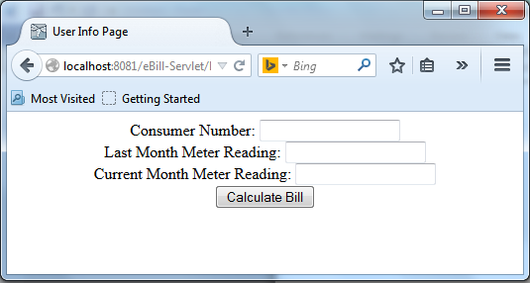
Figure 25

Following Client side validations need to be performed:
  - All fields are mandatory
  - Consumer number can contain only numbers i.e. 6 digit , Consumer number cannot start with 0
  - Last Month and Current Month meter reading can take decimal values, maximum 2 digits after decimal point and should not be negative
  - Current Month meter reading cannot be less than Last Month meter reading

Refer below figure with valid details:

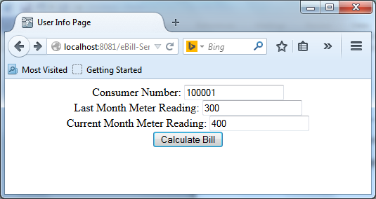

Figure 26

After user enters the valid details Units consumed and Net bill amount need to be calculated in servlet:

Refer below calculations:

Units consumed = (Last month meter reading) – (Current month meter reading)
Net Amount = Unit consumed * 1.15 + Fixed Charge

Assume Fixed Charge is always Rs.100.

After calculating the electricity bill, bill details needs to be inserted into the database table billdetails.

Note:
- Bill_id should be auto generated by sequence.
- Bill_date should be current date.

Print the following details for the Consumer. Refer below figure.
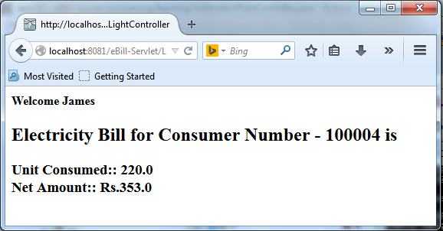

Figure 27

Following figure displayed the error in case of invalid consumer number entered

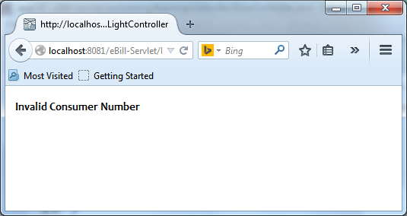

Figure 28

Layered architecture to be followed:

<<Controller>> EBillController

User_Info.html
<<Service>>
EBillServiceImpl
<<DAO>>
EBillDAOImpl
InfoView
BillDTO
DB

ErrorView

Figure 29

Appendix A: Table of Figures

Figure 1 6
Figure 2 7
Figure 3 7
Figure 4 8
Figure 5 9
Figure 6 9
Figure 7 10
Figure 8 10
Figure 9 11
Figure 10 12
Figure 11 12
Figure 12 13
Figure 13 13
Figure 14 14
Figure 15 14
Figure 16 15
Figure 17 15
Figure 18 16
Figure 19 16
Figure 20 17
Figure 21 17
Figure 22 18
Figure 23 18
Figure 24 19
Figure 25 22
Figure 26 23
Figure 27 24
Figure 28 24
Figure 29 25
Figure 30 26
Figure 31 27
Figure 32 28
Figure 33 28
Figure 34 29

